Iris with Github and Streamlit Cloud -Online Deployment
Cmd>python –version
Go to VS Code
D:>Iris Classification>Terminal
Create Python Environment
python -m venv venv
venv\Scripts\activate
create requiremens.txt
streamlit
scikit-learn
numpy
pandas
pillow

Run terminal: pip install -r requirements.txt
(or)
pip install numpy pandas scikit-learn streamlit pillow
SELECT PYTHON INTERPRETER (IMPORTANT) : Python 3.x (venv)
Create train_model.py
import pickle
from sklearn.datasets import load_iris
from sklearn.model_selection import train_test_split
from sklearn.ensemble import RandomForestClassifier

# Load data
iris = load_iris()
X = iris.data
y = iris.target

# Train-test split
X_train, X_test, y_train, y_test = train_test_split(
X, y, test_size=0.2, random_state=42
)

# Train model
model = RandomForestClassifier(n_estimators=100)
model.fit(X_train, y_train)

# Save model
with open("iris_model.pkl", "wb") as f:
pickle.dump(model, f)

print("Model trained and saved!")
Run Model
(venv) PS D:\Summer WS\Iris Classification> python .\train_model.py

Create app.py
import streamlit as st
import pickle
from PIL import Image

# Load model
model = pickle.load(open("iris_model.pkl", "rb"))

# Page config
st.set_page_config(page_title="Iris Flower Classifier", layout="centered")

# Title
st.title("🌸 Iris Flower Classification")
st.write("Enter flower measurements to predict the Iris species.")

# Input fields
sepal_length = st.number_input("Sepal Length (cm)", 0.0, 10.0, 5.0)
sepal_width = st.number_input("Sepal Width (cm)", 0.0, 10.0, 3.5)
petal_length = st.number_input("Petal Length (cm)", 0.0, 10.0, 1.4)
petal_width = st.number_input("Petal Width (cm)", 0.0, 10.0, 0.2)

# Prediction button
if st.button("Predict"):
input_data = [[sepal_length, sepal_width, petal_length, petal_width]]
prediction = model.predict(input_data)

labels = ["Setosa", "Versicolor", "Virginica"]
flower = labels[prediction[0]]

st.success(f"🌼 Predicted Flower: **{flower}**")

# Image mapping
image_paths = {
"Setosa": "images/setosa.jpg",
"Versicolor": "images/versicolor.jpg",
"Virginica": "images/virginica.jpg"
}

image = Image.open(image_paths[flower])
st.image(image, caption=flower, use_column_width=True)
Run
(venv) PS D:\Summer WS\Iris Classification> streamlit run .\app.py

Run Locally
Check values

Sample data

5.1 | 3.5 | 1.4 | 0.2 | Iris-setosa
4.9 | 3 | 1.4 | 0.2 | Iris-setosa
4.7 | 3.2 | 1.3 | 0.2 | Iris-setosa
4.6 | 3.1 | 1.5 | 0.2 | Iris-setosa
6.4 | 3.2 | 4.5 | 1.5 | Iris-versicolor
6.9 | 3.1 | 4.9 | 1.5 | Iris-versicolor
5.5 | 2.3 | 4 | 1.3 | Iris-versicolor
6.5 | 2.8 | 4.6 | 1.5 | Iris-versicolor
5.7 | 2.8 | 4.5 | 1.3 | Iris-versicolor
5.8 | 2.7 | 5.1 | 1.9 | Iris-virginica
7.1 | 3 | 5.9 | 2.1 | Iris-virginica
6.3 | 2.9 | 5.6 | 1.8 | Iris-virginica
6.5 | 3 | 5.8 | 2.2 | Iris-virginica
7.6 | 3 | 6.6 | 2.1 | Iris-virginica

Go to Github Repository
Create New Repository

app.py
iris_model.pkl
train_model.py
images/three images inside folder (while creating image folder click add file>create folder images/(must use /) and one new file named as temp->commit changes)
requirements.txt

Create Streamlit App

Deploy on Streamlit Cloud
- Go to https://streamlit.io/cloud
- Login with GitHub
- Select repo
- Main file: app.py
- Click Deploy

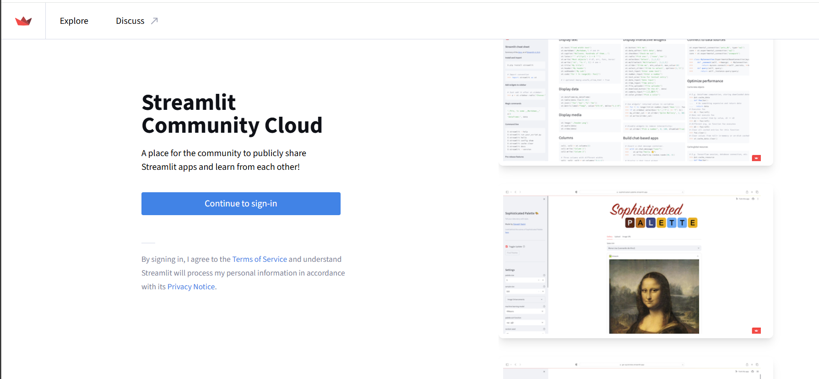

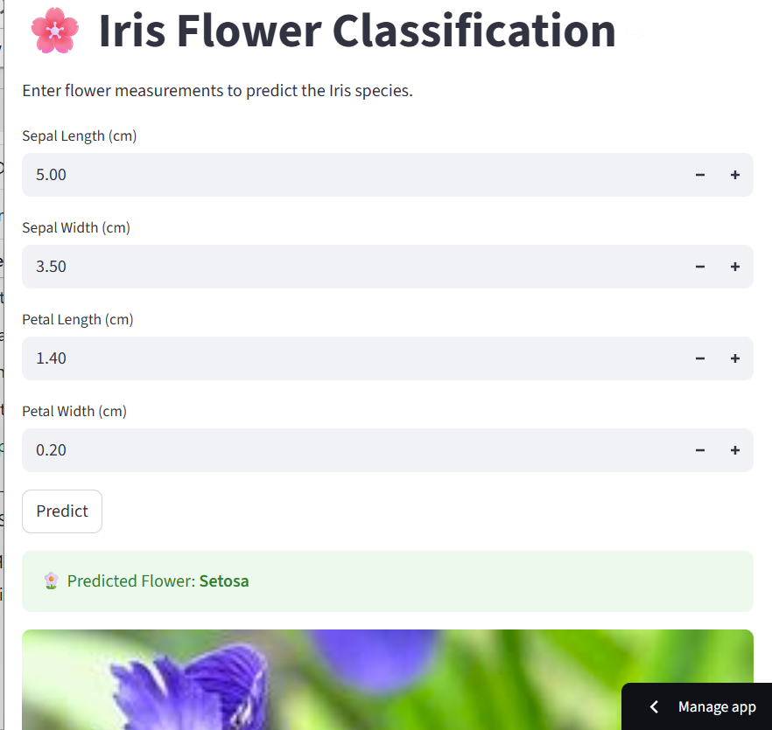
You get a public URL → works on mobile & desktop
Click share option

Copy link
